AP/ITEC 4220 A - Modern Approaches to Data Management: Database Management Systems
Milestone 1
Group 2

Wing Yan Kwan - 219474477
Victor Kwan - 216436990
Feng-Yuan Lee - 218501643
Brandon Lu - 218501254

Professor : Marina G Erechtchoukova
Submission Date: October 2nd, 2025

Problems:
As the number of gaming consoles and video titles continues to expand, small video game stores face growing challenges in accurately tracking sales and managing inventory. Many still rely on traditional practices, such as point-of-sale systems combined with manual stock counts, which often result in errors and inefficiencies. Implementing an online database system will make shopping easier for customers and help stores manage their inventory more effectively.
Scope:
The database will maintain and enforce data related to the product catalog, inventory, customers, orders, and suppliers. It will also integrate with an e-commerce platform to enable online purchasing, ensure accurate inventory tracking, streamline restocking processes, and provide reliable access to information for both customers and store staff.
Business Rules:
- Customer: Customers have a unique ID and must provide personal details such as name, contact, and email.
- Account: A customer must register an Account before using checkout, receipts, or order history.
- Shopping Cart: A ShoppingCart is managed by exactly one Account, but can exist independently as a guest session.
- Order: To make a purchase an Order must include at least one CartLine. Once an order is finalized, a receipt is generated. An Account can have multiple orders.
- CartLine: Each CartLine refers to a single product within the shopping cart, along with its quantity and price.
- PaymentMethod: An Account must have at least one valid PaymentMethod (Card or E-Transfer) to complete checkout.
- Product: Each Product has a unique id, name, and belongs to a category (Video Game, Console, Accessory), and price.
- Category: Each product belongs to a single category (Video game, Consoles, Accessories)
- Inventory: The system continuously monitors inventory levels, maintaining records of each product’s minimum and maximum thresholds and notifies the supplier whenever stock falls below the required level.
- Suppliers: Suppliers have a SupplierContract to provide games from their catalog and are responsible for shipping when inventory falls below the defined minimum. Suppliers information, including contact, and pricing is stored in the system.
User Views:
Customers
Data requirements
- Customer ID, name, contact, email, address
- Payment method (card, e-transfer)
- Orders (purchase)
Information requirements
- Browse games by name, category, availability, and price
- Track order status (pending, completed)
- Access receipts and past purchase history

Suppliers
Data requirements
- Supplier ID, Name, Contact details
- Product catalog (games offered, pricing, categories)
- Store restock requests (game, quantities, deadlines)
- Shipping records (deliveries to store)
Information requirements
- Manage incoming stock requests from stores
- Track shipment to stores
- Supplier Contract
- Update game availability and pricing in catalog

Class Diagram
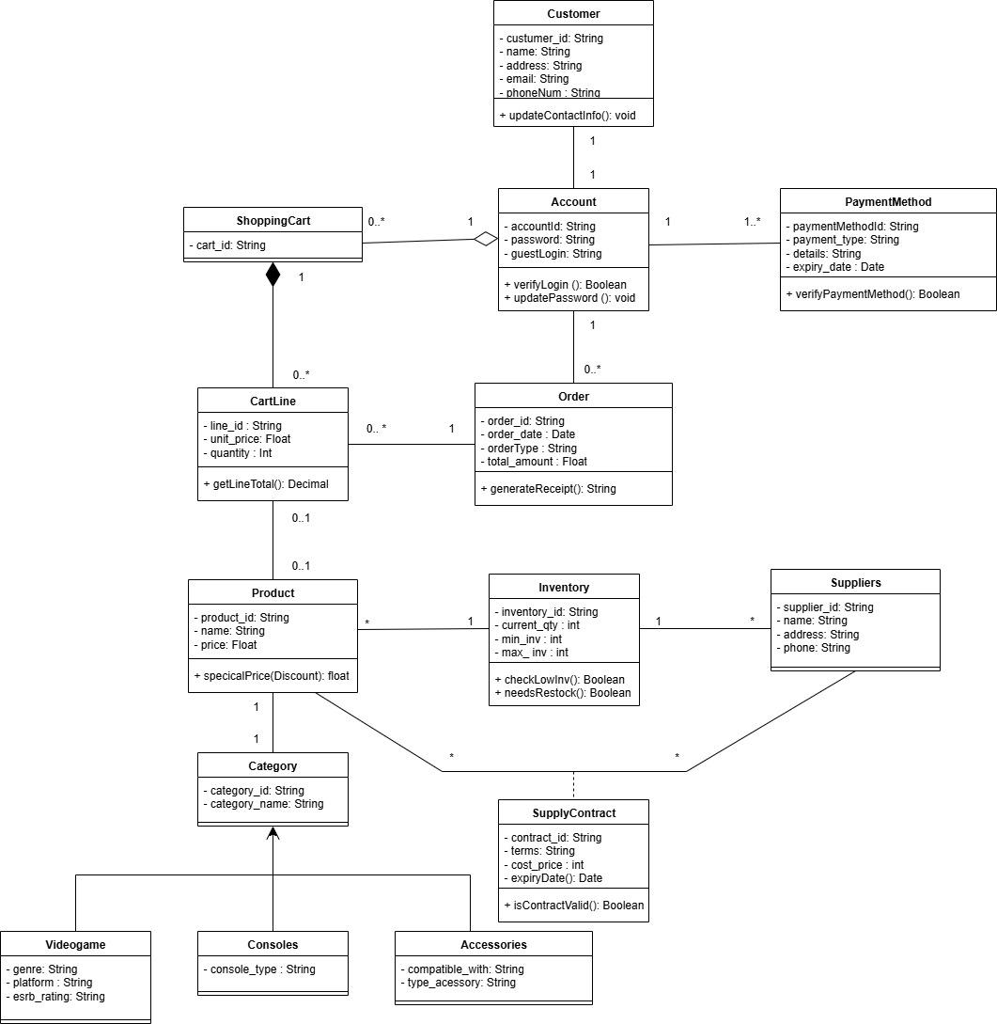

Peer Review
Student Names | Score
Wing Yan Kwan - 219474477 | 10
Victor Kwan - 216436990 | 10
Feng-Yuan Lee - 218501643 | 10
Brandon Lu - 218501254 | 10



